Atitit mybatis springboot 结合使用

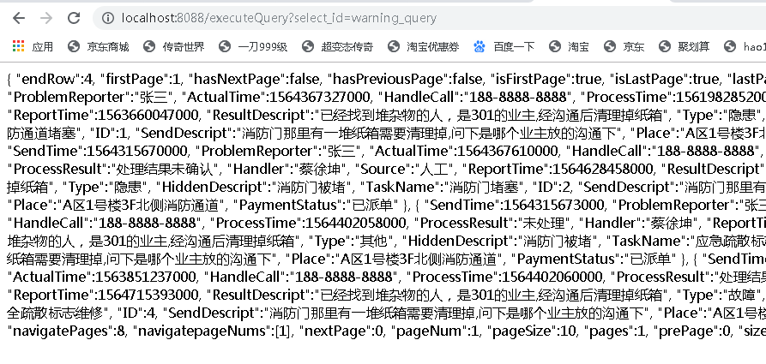

// http://localhost:8088/executeQuery?select_id=warning_query  
 @ApiOperation(value = "执行查询操作 通过接口", notes = "请求数据说明note")  
 @RequestMapping(value = "/executeQuery")  
 @ResponseBody  
 public String executeQuery(String select_id) throws Exception {  
 ResponseUtil.setAccessControlAllowOrigin(res);//setAccessControlAllowOrigin();  
 // com.github.pagehelper.PageInterceptor  
 try {  
 PageInfo pageInfo= MybatisUtil.executeQuery(select_id);  
 return (JSON.toJSONString(pageInfo,true));  
  
 } catch (Exception e) {  
 return ExceptionUtil. getEx(e);  
 }  
 //throw new RuntimeException("not imp");  
 }